4-Alexa Settings *(required time:15min)*

*this question should be answered with c#*

Your team is creating a home management system for Alexa, they want to be able to configure Alexa settings through the code. your boss passes you this code and ask you to complete it.

#### You can’t change the code below.

|  |
| --- |
| private static void **Main**(string[] args)  {  var alexa = new Alexa();  Console.**WriteLine**(alexa.**Talk**()); *//print hello, i am Alexa*  alexa.**Configure**(x =>  {  x.GreetingMessage = "Hello {OwnerName}, I'm at your service";  x.OwnerName = "Bob Marley";  });  Console.**WriteLine**(alexa.**Talk**()); *//print Hello Bob Marley, I'm at your service*  Console.**WriteLine**("press any key to exit ...");  Console.**ReadKey**();  } |

The output looks like this

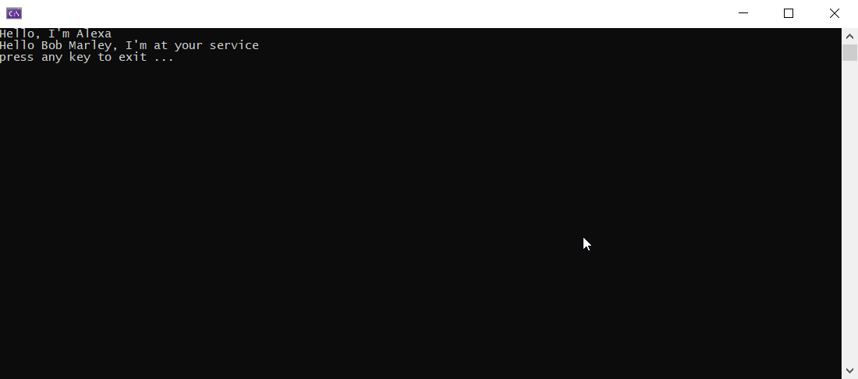

# Answer

Please find my answer in the attached code